

SIMATS ENGINEERING

Saveetha Institute of Medical and Technical Sciences
Chennai- 602105

Student Name: Kiruthika B Reg. No.: 192511232
Course Code: CSA0311 Slot: B
Course Name: Data structures
Course Faculty: Dr K Kiruthika
Project Title: Smart Parking Management and Predictive Space Allocation System Using Advanced Data Structures
Module Photographs:
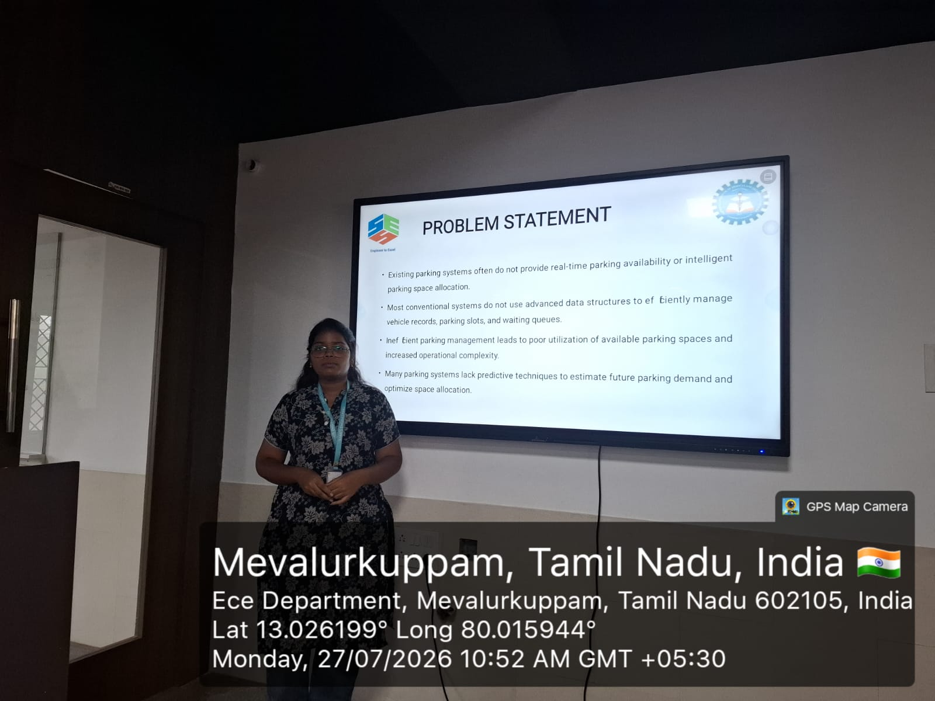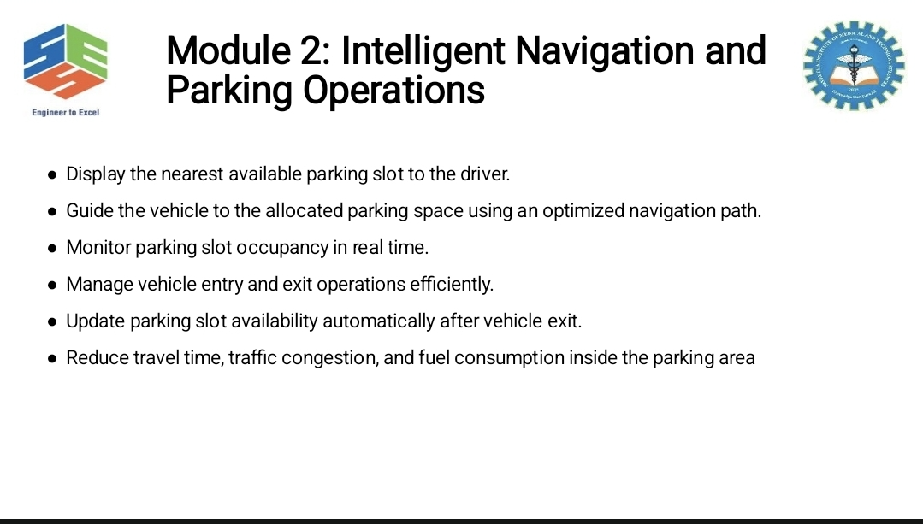
Project Description:
In this module, my contribution focuses on managing roles and permissions within the system. I worked on creating different roles such as Admin, Manager, and Employee. I assigned appropriate roles to registered users based on their responsibilities. I also worked on defining permissions for each role. The module ensures that users can access only authorized resources. Administrators can update or remove permissions when required. Role-based access control helps improve the security of organizational data. The module provides better control over user access. Roles and permissions are maintained systematically in the database. It reduces the possibility of unauthorized resource access. The module also helps administrators manage permissions efficiently. Proper role assignment ensures that users receive suitable access. It supports secure resource management throughout the system. This module plays an important role in controlling system access. Overall, it provides secure and organized role and permission management.

Kiruthika B
Student Signature Guide Signature

